ZIMBABWE SWIMMING BOARD OF CONTROL
2010/2011 SEASON REVIEW
Our Successes of the season. Provincial news, records broken, tours, Coaching, ZOC courses. National Meets and results.
50m Order of Merit.
31/03/2011
MASHONALAND
DEVELOPMENT SWIMMING.

A number of development programmes are in operation and vary from province to province.

Mashonaland have been developing school and club coaches on Friday afternoon prior to the their Friday night galas. This programmes has been very popular and will definitely be continued in some form.

Matabeleland hold development galas and invite all schools who have swimming pools to compete. Swimmers with talent are identified and club talent scouts try and bring them into the system.

Manicaland have been running a very successful Learn to Swim Programme at their City pool for many years and this is a hugely productive talent identification method.
Midlands are proactive in Triangle with the Sugar producers making every effort to keep children safe and ensuring that the community takes learning to swim as a priority as there are many canals filled with water in their area.
Keep us updated on development in your area.
Both the senior and junior programmes have gone well this season. Numbers at both galas appear to be going up and this bodes well for next season. Mash Champs continues to take up two weekends which again clashed with the Waterpolo activities and resulted in kids rushing between the two activites. The Mashonaland Board have undertaken the organisation of Senior Nationals and are responsible for sending out tours to both Level 1 and Level 2.
MATABELELAND
Regrettably numbers in the province are down this year which is very worrying. Friday night galas went according to plan with our invitation to Senior schools joining us on occasion working out very well, this idea will be encouraged again next season. Junior Nationals were held at North End pool a couple of weeks ago and went extremely well. The pool surrounds were given a massive overhaul but sadly, there are no clubs running there, a definite facility for anyone looking to establish a club, school etc. The Isemonger boys together Andy Cyprianos from Penguins broke records as did Mieke Koen from Crusaders.
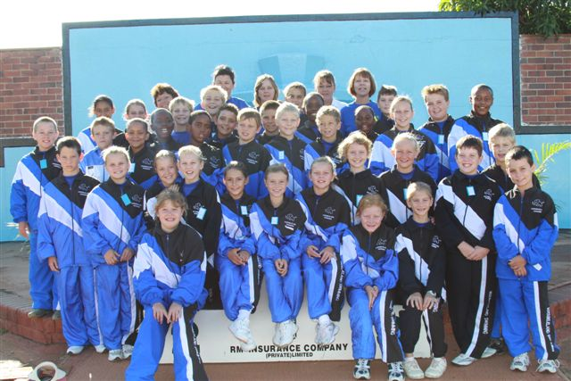
THE MATABELELAND JUNIOR TEAM 2011
MASH COUNTRY DISTRICTS
This year has seen growth in the number of senior competitive swimmers, at seeded galas, although at a junior level we have had fewer swimmers competing in Junior League galas in Harare. Senior Nationals was fairly successful for us with swimmers achieving PBs, a number of individual medals and also relay medals (we have the depth to “upset the apple cart” in a number of age groups and also to field 2 relay teams). For Junior Nationals we fielded a full team in all age groups. Most of our swimmers achieved PBs and a fair number made finals, although I think that this number was down on past years. We won 9 individual medals and were very proud of our 10 year old boys who won 2 gold relay medals!

Our growth in Senior level of swimming is reflected in the number of MCD swimmers who achieved required time/s necessary for the Level 1 and 2 Age Group Championships in South Africa and had the opportunity to travel with Mashonaland to these competitions: 7 at Level 1 and 13 at Level 2 (out of a total of 36 competitive Senior swimmers). They have maintained a high level of training so we hope that they achieve their goals at these competitions.

On the Junior side we are struggling with swimming in general starting at school level. We have tried to help, especially as far as technique is concerned, by organising mini-clinics for swimmers and coaches using our more experienced coaches. It is a long process and one we will endeavour to maintain.

Several of our coaches attended and qualified at the Beginners and Intermediate Coaching Courses run by the Zimbabwe Olympic Committee.
Thanks to ZOC via the Olympic Solidarity Fund for sending us Josh Neuloh who conducted both a beginners and an intermediate coaching course in Harare. There were a total of 35 interested parties at the beginners’ course and 19 on the Intermediate. Thanks to Mary Kloppers for her amazing organisation of the course. Congratulations to all those who attended and learned so much!

MIDLANDS.
Midlands have had quite an exciting season this year, a number of new faces have emerged, old faces have returned and next season will be more interesting than ever. Aquarium swimming club opened their doors this season in Gweru, sharing the Midlands Christian School pool with Maple Leaf, their fearless leaders are bounding with enthusiasm and will be taking their swimmers to Harare for a clinic in April. Graham Pallister and Sherlyn
OFFICIALS NEWS DESK.

An all out effort was made by Caroline Hawgood this season. It began with a clinic following her trip to the symposium in Singapore, where all our local officials had the opportunity to hear about changes to the rules and regulations that govern our sport.

Some 15 timekeepers were qualified in Mashonaland this season and 1 Chief timekeeper, congratulations to them all.

Matabeleland had a determined drive for qualification and had
10 new timekeepers, 1 Chief Timekeeper, 7 Judges of Stroke and one Inspector of Turns.

The only major controversy of the season was the positioning of the butterfly kick within the breaststroke pull, with the world cup clearly showing swimmers inserting the kick before the arm stroke and not being disqualified! In Dubai FINA technical expert Don Blew was very clear that this would not be allowed and the rules state “ a single butterfly kick is permitted DURING the first arm stroke, followed by a breaststroke kick” and that this was to be strictly enforced.

Next season short individual clinics will be given to people interested in learning a particular role, i.e. a stroke judge clinic or a chief timekeeper’s clinic. Hopefully Caroline will be able to take her clinic around to other provinces next season too.

Her ultimate wish for next season is that parents of junior swimmers are able to run galas for those swimmers and give parents of senior swimmers some time off!

Visage both ex Midlands swimmers are back in Hippo Valley and taking an interest in swimming from a coaching perspective and Heather Brand the 27 year old former Olympic swimmer is also working in the vicinity and we hope to learn from her experience in some way next season.

MANICALAND
We held our Manicaland Championships in November last year and were able to incorporate more non-club members from the local private school which gave us a better range to select a Manicaland Squad from. Local government schools were invited but failed to appear. 7 swimmers made Level 1 times this year and for the first time in many years one swimmer achieved Level 2 times. With the help of community fund raising we are able to send all of the swimmers who were able to go.

We attended both Senior and Junior Nationals, with small, but enthusiastic squads. Most of our Senior swimmers achieved personal bests. A lot of our Junior swimmers were first timers and overawed by the whole experience . Our Head Coach Anneke ChanJack was indisposed due to ill health for a couple of months this half of the season, but we were pleased to welcome back Natalie Ratcliffe to help with Squad training. She was also able to attend the FINA Intermediate clinic and has come back brimming with knowledge to pass on to us all. A fairly successful season, thanks to everyone pulling together!

ZIMBABWE TOURS
ZONE 6
A number of exciting went out this season, starting with the Government sponsored and organised Zone 6 team who travelled to the Youth Games in Swaziland in early December 2010. We sent a team of 11 Swimmers, with 2 coaches (Dion Kruger and Lindsy Tudor Cole) with Manager Claire Carey Smith and technical staff Kim Rennie and Gareth Desmond. They returned home victorious with 2 Gold medals, 2 silver medals and approximately 10 bronze medals to their credit. It was a difficult tour which triumphed despite their setbacks.

WORLD CHAMPS DUBAI
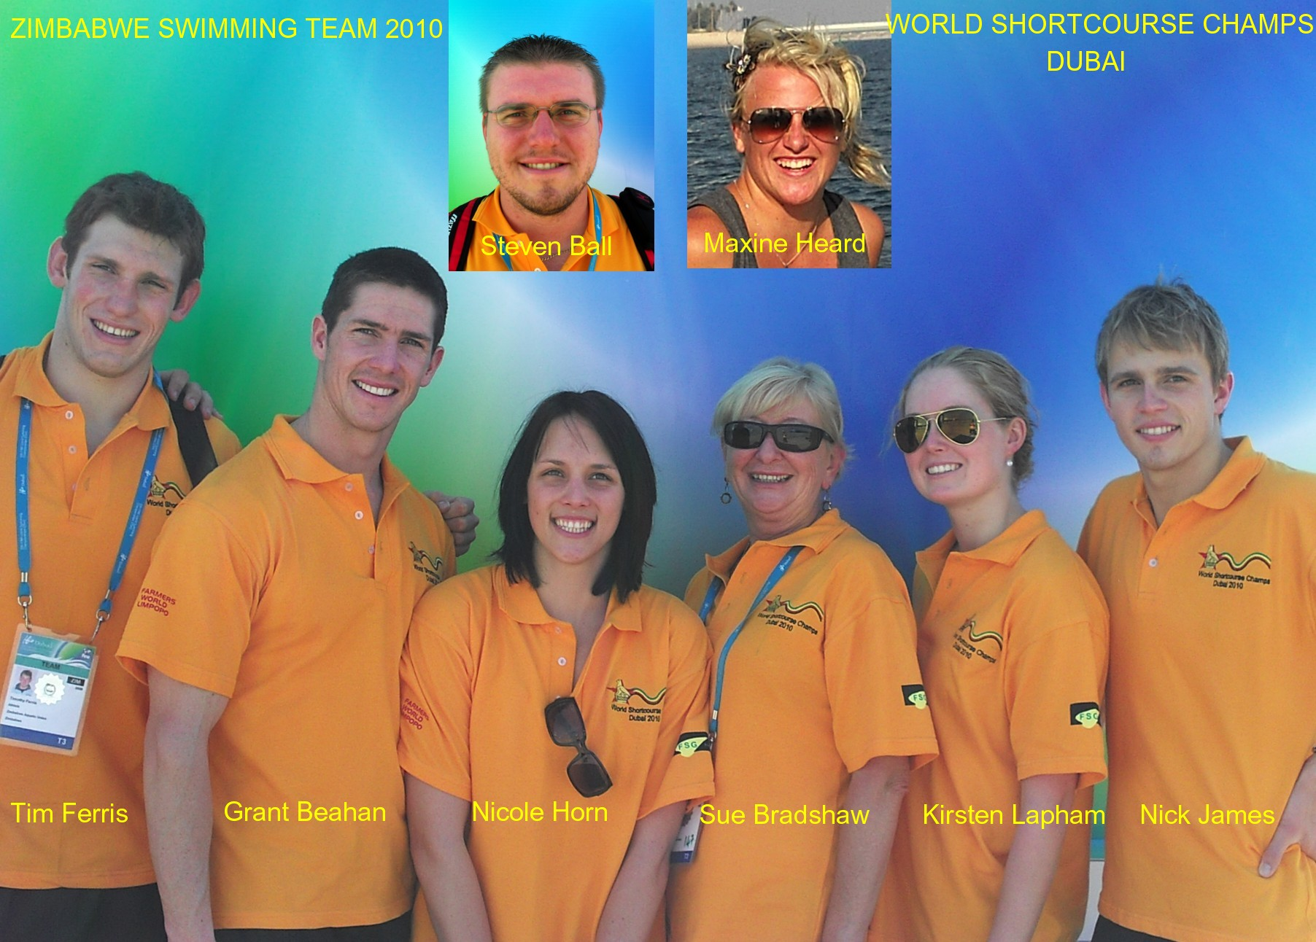
This team of senior swimmers, Grant Beahan, Tim Ferris, Nick James, Kirsten Lapham, Nicole Horne and Maxine Heard assembled in Dubai on Sunday 12th December 2010 to compete in the World Short Course Championships. Lorna Riley (Manager) and Sue Bradshaw accompanied the swimmers and had a wonderful time seeing the sights and competing in the brand new and fantastic facility built for the occasion. Results were wonderful for the boys with almost every swim a new national record!

CANA 3 & 4 GABERONE, BOTSWANA
Mary Kloppers, Julie Price and Di Stirling set off with 36 swimmers to take part in the latest African encounter. Results were good at the well organised event in Gaberone and we again came a creditable second to the host nation despite the comparative sizes of the teams! This event is becoming more and more competitive and is definitely a gala more senior swimmers should once again consider.

LEVEL 3 : DURBAN, SOUTH AFRICA
This team left in the safe hands of Julie Price and Sheelagh Crause on Wednesday 16th April to compete in the annual Age Group bonanza. The team consisted of 10 swimmers, 5 from Mash and 5 from Matland and results were very satisfying. Good times were achieved by all swimmers. Nick Burnett achieved a couple of bronze and Luke Isemonger after several 4th places finally achieved a bronze as well.
PROVINCIAL TOURS
The Fina Aquatics Mag 2010/5 reported that Kirsty Coventry has signed with Arena until 2013

LEVEL 2
Mashonaland had a large contingent travelling to the Level 2 affair at Hillcrest pool in Pretoria. The team of 45 went with Tracey Doorman and Sandy Weaver managing, and Sue Bradshaw and Mairead Goncalves coaching. Matabeleland could only convince 3 swimmers to attend.
Records this season!
Records have tumbled this season especially in the short Course arena with a total of 157 National records falling and 131 provincial! Long course records which can be deemed a little more difficult to break considering how much older they are have also taken a hit with 41 National and 19 provincial records falling. This shows that swimming is getting stronger and stronger.

The majority of these records fell at meets held outside the country – S A Short course in Pietermaritzburg accounted for 88, Mash short course 100, zone 6 48 and of course World Champs 13. Long course records fell regularly but in smaller numbers with the KZN Provincial Champs being the major provider with a total of 31 records falling.

Congratulations to you all!

LEVEL 1
Border Dolphins from Mutare have a team of 6 swimmers attending the Central Gauteng Level 1 Champs being swum at Delville Pool, Matabeleland have 5 swimmers and Mashonaland have a team of 30 swimmers under the management of Jackie Quinlan and Nicky Hultum.
WHATS HAPPENING NEXT!
S A Champs, Port Elizabeth.

World Long Course Champs, Shanghai China – JULY 2011. Swimmers have been provided with the qualifying times for this event but as yet only Kirsty Coventry has qualified.

Junior World Champs, Peru – AUGUST 2011pent or the summary of an interesting point. You can position the text box anywhere in the Use the Text Box Tools tab to change the formatting of the pull quote text box.]
All Africa Games, Maputo, Mozambique – SEPTEMBER 2011

Swimmers hoping to take part in the London Olympic Games are obligated to attend both the World Championships in China and their Continental Games so the pressure to qualify is on!
ZIMBABWE OLYMPIC COMMITTEE ADMIN COURSE : 18 – 20TH MARCH 2011.
Various members of the Swimming fraternity attended a ZOC Sports Administration course to update our administration skills at both National and Provincial level thereby ensuring that we remain compliant!
THANK YOU OLYMPIC SOLIDARITY

BELOW ARE THE 50M RANKINGS FOR GIRLS AND BOYS FROM SEPTEMBER 2010 TO SENIOR NATIONALS 2011. THEY WILL BE UPDATED AFTER THE SPRINT CHAMPS NEXT SEASON.

GIRLS 50M FREESTYLE
- SAM WELCH 29.07
- TARRYN RENNIE 29.09
- NATS DE CHASSART 29.21
- KAYLEIGH GRAHAM 29.31
- SYANNE GRAHAM 29.38
- MEGAN C-SMITH 29.70
- NATASHA RUSCH 29.80
- ALEXA MORRISBY 29.90
- SARAH THOMSON 30.05
- MIEKE KOEN 30.42
- KIM BELLRINGER 30.57
- SHANICE BUYS 30.86
- BREE CATTERALL 30.89
- RATI MUTANGADURO 30.98
- SIOBHAN H-DAVIES 31.09

GIRLS 50M BACKSTROKE
- TARRYN RENNIE 33.44
- AVALON BRUCE 34.89
- SAM WELCH 35.64
- NICOLE CILLIERS 35.72
- RATI MUTANGADURA 35.92
- ALEXA MORRISBY 36.13
- SIOBHAN H-DAVIES 36.32
- NATS DE CHASSART 36.32
- MEGAN C-SMITH 36.73
- MAXINE ZIEHL 37.11
- LORNA DOORMAN 37.14
- SARAH THOMSON 37.71
- MIEKE KOEN 37.83
- MISTY BATCHELOR 37.86
- AMY CHANJACK 37.89

GIRLS 50M BREASTSTROKE
- SYANNE GRAHAM 35.55
- SAM WELCH 35.80
- MARY HAWGOOD 37.69
- NATASHA LAWSON 38.61
- ROBIN MASON 38.75
- MIEKE KOEN 38.98
- TARRYN RENNIE 39.26
- SHANICE BUYS 39.67
- MISTY BATCHELOR 39.92
- KIM BELLRINGER 39.92
- MIKAYLA QUINLAN 40.07
- NICOLE CILLIERS 40.07

BOYS 50M FREESTYLE
- NICK BURNETT 25.39
- SEAN GUNN 25.74
- RICHARD WELSH 26.08
- SLOANE MARSHALL 26.23
- JAMES LAWSON 26.48
- LEBO NGWENYA 26.51
- MARC ROSS 26.73
- LUKE ISEMONGER 26.75
- BRIAN WHITE 26.82
- CHAD IDENSOHN 26.87
- ANDY CYPRIANOS 27.25
- FRANK LANG 27.28
- MATT WEAVER 27.89
- TREVOR PRICE 28.11
- RYAN B-ROGERS 28.16

BOYS 50M BACKSTROKE
- NICK BURNETT 29.64
- TREVOR PRICE 30.86
- CHAD IDENSOHN 31.23
- ANDY CYPRIANOS 31.23
- LUKE ISEMONGER 31.32
- FRANK LANG 31.57
- SEAN GUNN 31.81
- JAMES LAWSON 32.26
- MARC ROSS 32.48
- SLOANE MARSHALL 32.51
- A J STAMBOLIE 33.01
- BRIAN WHITE 33.20
- PETER WETZLAR 33.22
- COREY SCHULTZ 33.61
- KYLE MITCHELL 33.80

BOYS 50M BREASTSTROKE
- JAMES LAWSON 30.32
- LUKE ISEMONGER 31.51
- RICHARD WELSH 32.57
- KYLE MITCHELL 33.14
- CONNOR PRITCHARD 33.76
- JAMIE ISEMONGER 34.73
- BRIAN WHITE 34.83
- DOUG GRINHAM 35.16
- TOM HILL 35.80
- A J STAMBOLIE 36.67
- NARDUS BRITS 36.67
- NICK BURNETT 37.61

GIRLS BREASTSTROKE CONTINUED

- LAURIE STEPHENS 40.36
- MEGAN C-SMITH 40.61
- ANNE STACK 40.77

GIRLS 50M BUTTERFLY

- TARRYN RENNIE 30.32
- ALEXA MORRISBY 30.89
- KAYLEIGH GRAHAM 31.19
- SAM WELCH 31.39
- SYANNE GRAHAM 31.99
- MEGAN C-SMITH 32.09
- NICOLE CILLIERS 32.71
- AVALON BRUCE 32.95
- RATI MUTANGADURA 33.01
- MIEKE KOEN 33.16
- ROBIN MASON 33.97
- NATS DE CHASSART 34.07
- CERISE DINGISWAYO 34.22
- BREE CATTERALL 34.51
- NATASHA RUSCH 34.54

BOYS BREASTSTROKE CONTINUED

- MARC ROSS 37.67
- FRANK LANG 38.09
- LEBO NGWENYA 38.09

BOYS 50M BUTTERFLY

- SLOANE MARSHALL 27.73
- ANDY CYPRIANOS 28.09
- MARC ROSS 28.16
- SEAN GUNN 28.23
- JAMES LAWSON 28.45
- NICK BURNETT 28.83
- LEBO NGWENYA 29.11
- LUKE ISEMONGER 29.37
- FRANK LANG 29.70
- CHAD IDENSOHN 29.71
- KYLE MITCHELL 29.83
- TREVOR PRICE 29.98
- BRIAN WHITE 30.32
- PETER WETZLAR 30.86
- MATT WEAVER 31.20

NATIONAL GALA RESULTS
Comments and submissions can be e mailed to : editor.swimzim@gmail.com

Mutare Sprint:

1st Place Sharks Swimming Club 262.5
2nd Place Crusaders Swimming Club 182
3rd Place Penguins Swimming Club 179
4th Place Pirates Swimming Club 176.5
5th Place Highlands Swimming Club 144

National Senior Championships

1st Place Mashonaland 2963
2nd Place Matabeleland 1356.5
3rd Place Mash Country Districts 381.5

Aggregate Matabeleland

National Junior Championships

1st Place Mashonaland 1044.5
2nd Place Matabeleland 779
3rd Place Mash Country Districts 382.5

Aggregate Matabeleland

